Domain Eukarya Kingdom Plantae:
Nonvascular (Seedless) Plants
The evolution of plant, multicellular photosynthetic eukaryotic organisms, has been marked by adaptation to a dry land environment. They are thought to be the decedents of green algae with the charophytes, being the algal member that is most closely related to the land plants we see today.

LAND PLANTS: THE EMBRYOPHYTES
Land, unlike water, is very dry. In order to survive the move from water to land, plants have had to undergo many adaptations and only those plants that were successful in protection ALL phases or reproduction (sperm, egg, zygote, and embryo) have survived. The plants that have protected their embryos are known as the Embryophytes. Other adaptations include waxy cuticles to prevent desiccation and vascular tissue to transport water and offer support.
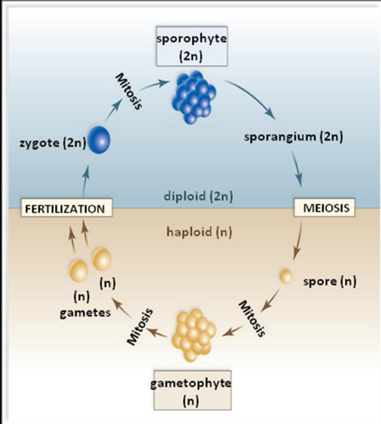
Plants undergo the Alternation of Generations Life Cycle:
2- generation life cycle. Unlike animals, plants spend their adult life cycle as either a haploid or a diploid organism. The diploid stage is called the Sporophyte Generation (2n). The sporophyte will then undergo meiosis and produces haploid cells. These haploid cells are now called the Gametophyte generation (n)
The haploid cells of the gametophyte generation (Eggs and sperm) will unite to make (2n) zygote during fertilization.

NONVASCULAR PLANTS (THE BRYOPHYTES)
LIVERWORTS, HORNWORTS, MOSSES
The nonvascular plants include mosses (Phylum Bryophyta), liverworts (Phylum Hepatophyta) and hornworts (Phylum Anthocerophyta). The gametophyte is the dominant generation, meaning that plants in Bryophytes will spend slightly more time as a gametophyte than a sporophyte.
The gametophyte has eggs inside of an archegonium. The antheridia contain flagellated sperm. The sperm is going to swim into the archegonium to fertilize the egg. The sporophyte will then grow out of the archegonium. Without the archegonium the sporophyte cannot grow, so it is said to be dependent on the archegonium.
Marchantia is a liverwort.

STRUCTURE: ARCHEGONIA
Domain: Eukarya
Kingdom: Plantae
Group: bryophytes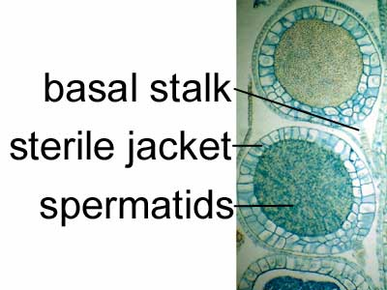
Phylum: bryophyta
Genus: Marchantiaceae

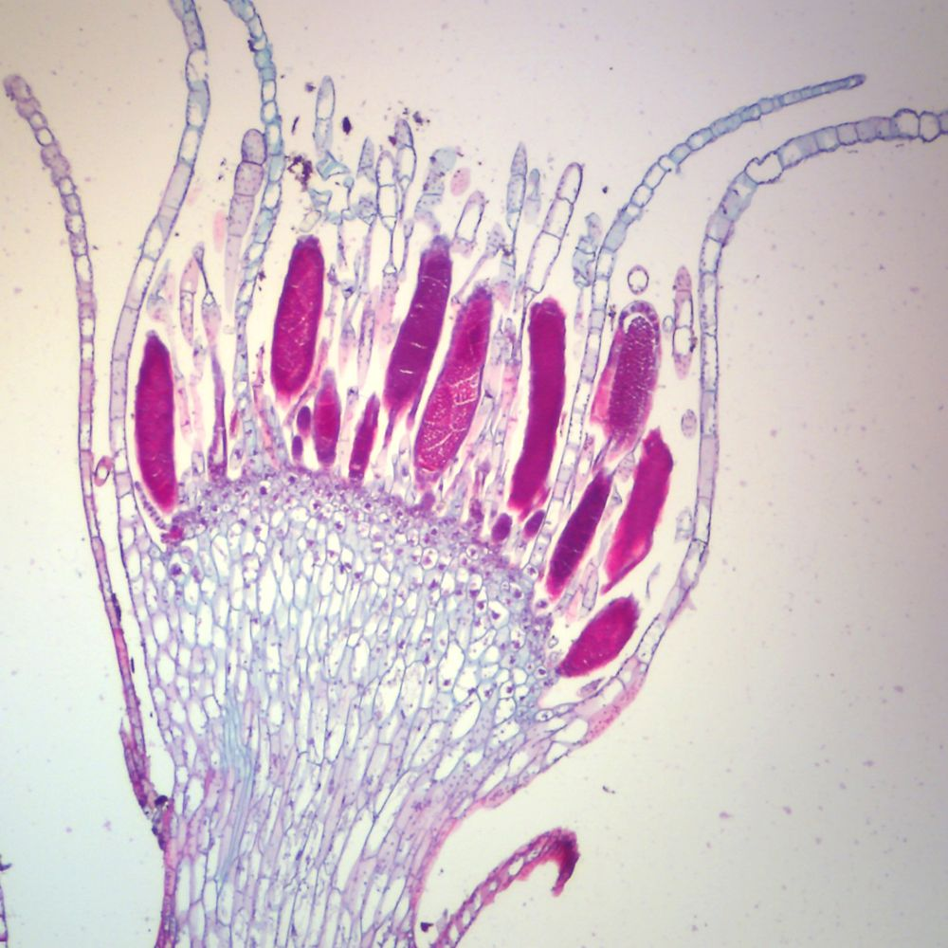
STRUCTURE: ANTHERIDIA
Domain: Eukarya
Kingdom: Plantae
Group: bryophites
Phylum: bryophyta
Genus: _________ Marchantiaceae ______

STRUCTURE: SPOROPHYTE
Domain: Eukarya

Kingdom: Plantae
Group: _____byrophytes__________
Phylum: __bryophyta.____________
Genus: _marchantiaceaae.______________

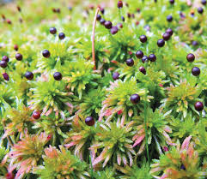
https://encrypted- https://encrypted-tbn0.gstatic.com/images?q=tbn%3AANd9GcRcpBZeXnMCcP77s42fgDhif5qp3ePN7L9VKw&usqp=CAU tbn0.gstatic.com/images?q=tbn%3AANd9GcRcpBZeXnMCcP77s42fgDhif5qp3ePN7L9VKw&usqp=CAU

Mnium is a Moss. Find a slide of Mnium male, female and sporophyte.
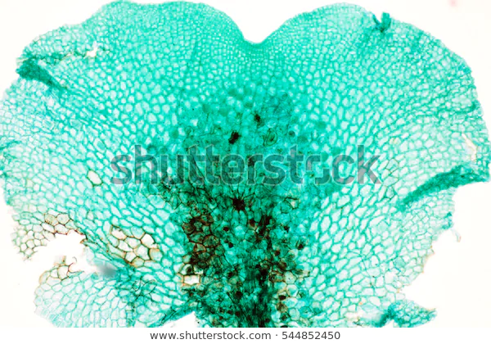

STRUCTURE: ARCHEGONIA
Domain: Eukarya

Kingdom: Plantae
Group: ___moss____________
Phylum: __bryophyta____________
Genus: _______mnium________

STRUCTURE: ANTHERIDIA
Domain: eukaryote_____
Kingdom: _plantae_
Group: ___liverwort _ 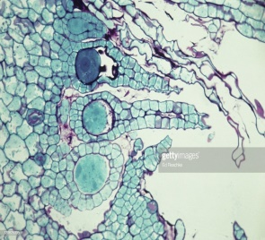
Phylum: _hepatophyta
Genus: merchantia______

STRUCTURE: SPOROPHYTE
Domain: _eukaryo 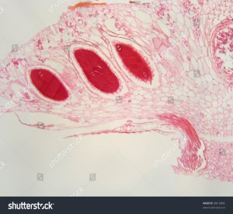
Kingdom: _plantae_______
Group: ____liverwort____
Phylum: _____hepatophyta_
Genus: ______merchantia_

Look for a live specimen of moss on the internet and place it here

Domain: _Eukaryote_
Kingdom: ____Plantae___ _ 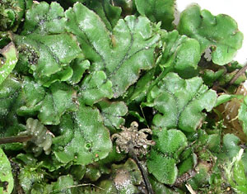
Group: _moss__________
Phylum: __Bryophata______
Genus: ___Mnium____________

